RF EW – SYSTEM TEST

RADAR TEST PLAN

Team:
Finck BIG!

Team Members:
Bryan Finck, David Horne, Carlos Lazo, Rowland Stilwell

Course: TDC1 – RF EW System Test
Instructor: Brian Smith

Date Submitted: March 24th, 2009
INTRODUCTION

This Radio Detection and Ranging (RADAR) test plan includes information and tasks that will be performed by personnel of Team Finck BIG! In developing an Early Warning (EW) RADAR system, Patuxent River test site was selected based on range size, average temperature, and target availability. This test plan describes procedures to test system requirements involving simultaneous target detection at the RADAR’s maximum detection range.

The measurement procedures in this plan are intended as guidance. As the team gains experience in understanding the characteristics of our system and how different environmental factors affect operation, they may develop alternative measurement procedures or make additional measurements to those described here.

TIS01

simultaneous detection of multiple targets at maximum radar range

Requirements

Test Information Sheet (TIS01) defines the procedure to verify the requirements associated with the RADAR performance when engaging simultaneous targets. The SYS-xx value is the unique Requirement Identifier.

ID | Paragraph Number | Paragraph Title | Requirement Specification | Req Type | Qual Method
SYS-01 | 3.2.2.3.1 | Simultaneous Detection of Multiple Targets | The RADAR shall have a maximum detectable range of at least 194.865 km | Prime (spec) | T
SYS-04 | 3.2.2.3.1 | Simultaneous Detection of Multiple Targets | The RADAR shall be able to detect a target with a minimum RADAR Cross Section (RCS) of one square meter | Prime (spec) | T
SYS-06 | 3.2.2.3.1 | Simultaneous Detection of Multiple Targets | The RADAR shall be capable of detecting multiple targets which are at least 180m apart at the maximum range. | Prime (spec) | T
SYS-10 | 3.2.2.3.1 | Simultaneous Detection of Multiple Targets | The RADAR shall be capable of detecting the azimuth angle, elevation angle, and range of a target | Prime (spec) | T
SYS-16 | 3.2.2.3.1 | Simultaneous Detection of Multiple Targets | The RADAR shall store detection data every .001 seconds. | Prime (spec) | T

Test Description

The requirements described in this Test Plan will be verified at the selected test location by having two targets fly pre-planned routes to test various aspects the RADAR detection system. The plan will test three conditions:

- Targets outside of maximum detectable range
- Targets at maximum detectable range without minimum range resolution between them
- Targets at maximum detectable range with greater than minimum range resolution between them.

In order to appropriately measure the time difference when a unique signal is transmitted and received, a radar cross section (RCS) reflector of 1 m² will be used calibrate the RADAR. With the main beam of the RADAR pointed at the reflector, a latency (lag) time of transmit vs. receive will be determined. This time must be taken into account when performing post-processing data operations since the RADAR cannot transmit and receive a unique pulse (signal) at the same point in time.

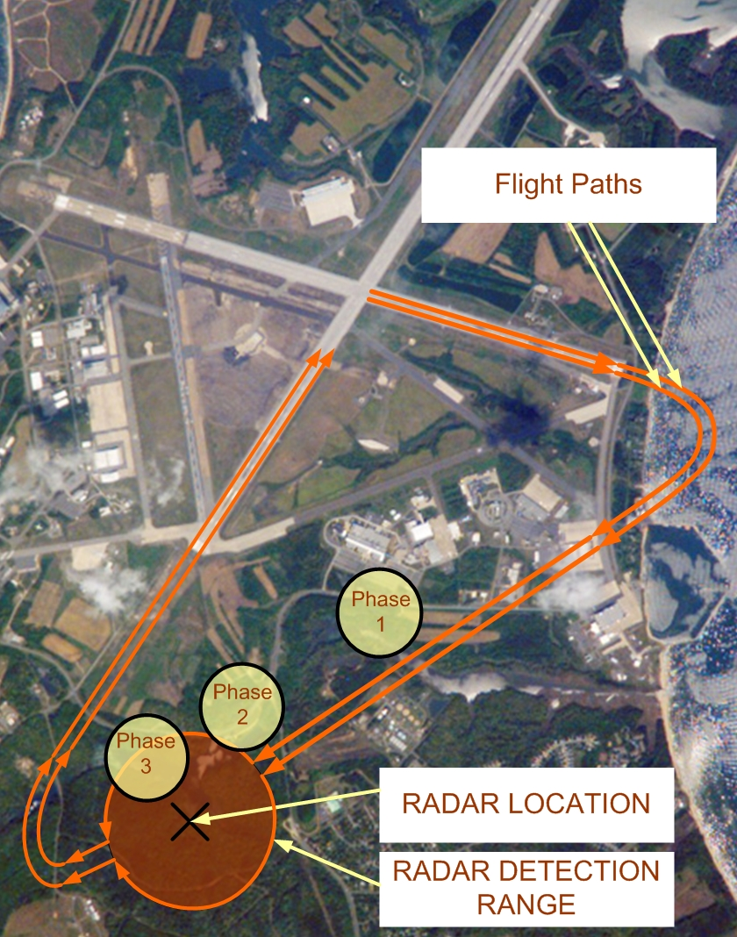
In order to successfully test all three conditions, a specific RADAR scan strategy was developed. Given that the area of interest (AOI) is fairly narrow and given a RADAR beamwidth of 2 degrees, a narrow sector scan strategy was selected. In this scan, the RADAR oscillates back and forth in half degree offsets, aiming the main beam almost directly at our AOI at all times. Since the targets will always be located at 30,000 ft in altitude, the RADAR will only be panning in azimuth and not in elevation.

Test Location

The RADAR tests will be performed at Patuxent River test site in Maryland. The determination was made based on available airspace and temperature. The required site attributes are listed below, along with

Site Attributes | Required | PAX River
Range | 400 km² | 5.9 x 10⁴ km²
Target Altitude Limit | 9.144 km | 25.9 km
RADAR Altitude | Sea Level | Sea Level
Nominal Operating Temperature | 16°C | Month: October  Nominal: 16°C  Range: 12-20°C
Airspace | 2.5 x 105 km² | 7 x 10⁹ km2

Test Time & Date Approximation

Testing should take approximately 2-3 days and will be performed on Saturday, October 24th, 2009.

Flight Description

Using JUMPS mission planning system, a flight path was outlined at Patuxent River as seen in the figure above. Each of the three phases corresponds to a different condition this plan seeks to test.

Test Equipment and Tools
The BAE test equipment will be used during the test procedure:

TIS01 Test Equipment and Tools

Description | Manufacturer | Model / Part #
F-16 C with GPS Recorder and COMM Radios (x2) | Lockheed Martin Corporation | R2D2
RCS Reflector with GPS Recorder | Northrop Grumman | C3PO
Ground COMM Radio Receiver at RADAR Station | BAE Systems | 10-10-321
Scorpion RDS Ruggedized Portable Maintenance Aide | DRS Technologies | 8675309
Perl Script for Data Fusion CM226 | BAE Systems | RADAR_dfuse.pl

TIS01 Test Equipment Setup

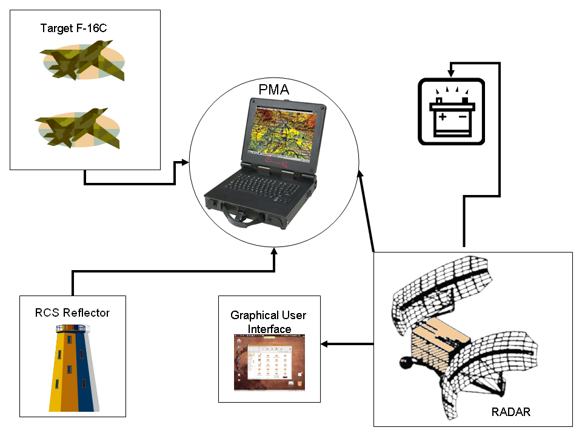

Required Personnel

Title | Required Personnel | Effective Man Hours
Software Engineer | 1 | 16 Hours
Systems Engineer | 2 | 32 Hours
Technical Support | 3 | 26 Hours
Ground Crews (3) | 6 | 5 Hours
F-16C Pilots | 2 | 8 Hours
Total | 10 | 87

Test Preparation

- F-16 C Configuration
  - Fully fuel two F-16 C aircrafts.
  - Perform Built-in Test (BIT) and ensure aircrafts are flight-ready through cockpit indicator lights.
  - Attain approval for flight plan on day of test.
  - Ensure internal GPS device is calibrated.
- RADAR Setup
  - Ensure power source has valid calibration and is ON.
  - Run Radar Built-In Test (BIT) and ensure Status BIT is green, indicating the system is fully operable.
  - Set the RADAR parameters as specified in the ‘RADAR Parameters & Specifications.xls’ on touch user interface.
  - Using the RADAR graphical user interface (GUI), load the test mission’s scan strategy.
  - RADAR will oscillate by .5 degrees off boresight at targeted area of interest (AOI).

- Measurement Equipment Setup
  - Ensure that GPS recorder on the targets is fully operational and calibrated.
  - Ensure that RCS reflector GPS power source has valid calibration and is ON.
  - Ensure that RCS reflector is at maximum range from RADAR.
    - Test that RCS reflector is seen on RADAR graphical user interface (GUI) at maximum distance.
    - If RCS reflector is not seen, then do not perform RADAR test.
  - Ensure that PMA battery is fully charged.

Measures of Effectiveness

- Binary detection of RADAR Cross Section (RCS) Reflector
  - Detection of RCS Reflector proves RADAR is operational
  - Accurate calculation of latency at maximum range

- Consistency between the target and RADAR detection ranges
- Number of targets detected by the RADAR

Expected Results

- The RADAR shall have a maximum detectable range of at least 194.865 km
  - When the targets are outside the maximum range of the RADAR, they will not be detected
- The RADAR shall be able to detect a target with a minimum RADAR Cross Section (RCS) of 1 m²
  - Targets with an RCS of at least 1 m2 will be detected by the RADAR
- The RADAR shall be capable of detecting two targets which are at least 180m apart at the RADAR’s maximum detectable range
  - Aircrafts within the arc of the RADAR’s maximum range will be detected as one target if they are not flying at least 180 m apart from one another
  - Aircrafts flying within the arc of the RADAR’s maximum range will be detected as two separate targets if they are at least 180 m apart from one another
- The RADAR shall be capable of detecting the azimuth angle, elevation angle, and range of a target
  - The time-tagged position detection data of the RADAR should match that of the target platform
- The RADAR shall store detection data every 0.001 seconds
  - Data recordings should be made at every 0.001 seconds

Assumptions and Constraints

- RADAR begins to pulse instantaneously once RF is enabled.
- Latency time to a target is assumed to be the time it takes for a unique signal to reflect off the target and be received back at the RADAR.
- The latency difference of a target on the ground or at 30,000 feet, located at maximum RADAR range, is negligible.
- RF cascade of our RADAR transmit/receive architecture is lossless.
- Mechanical vibration of RADAR scan strategy is negligible and will cause no significant performance loss to the system.

SIMULTANEOUS DETECTION OF MULTIPLE TARGETS AT MAXIMUM RADAR RANGE

Step | Test | Req ID | Expected Result | Result | Pass/  Fail Status
1 | At time TBD, F-16 C pilots ensure aircraft is ready for flight and commence the flight path.  Also, the configured RADAR will be turned on and will commence its pre-loaded scan strategy.  The configured radar cross section (RCS) reflector with a RCS reflector of 1 m² will be turned enabled. | NA | F-16 C pilots successfully begin to navigate on the proposed flight path.  RADAR will be visibly active and will be scanning at the area of interest.  RCS reflector will be enabled and will have an RCS of 1 m².
2 | At time TBD + 5 seconds, deactivate RCS reflector, effectively taking the RCS to 0 m². | NA | RADAR operator verifies that there is no detection present where the known RCS reflector was located via the RADAR graphical user interface.
3 | Both F-16 C pilots will announce, “Midway point reached {Call ID},” to the RADAR operator once they have passed the midway point of their banked turns. | NA | Coherent radio audio is heard by operator at RADAR COMM station.
4 | RADAR COMM operator will reply, “10-4,” after receiving confirmation from both F-16 C pilots. | NA | RADAR COMM operator will confirm receipt of F-16 C announcements.
5 | Utilizing operator GUI, deactivate current scan strategy and disable RF transmission. | NA | RADAR will visibly stop scanning and the RF transmission light would turn red.
6 | Center RADAR to boresight of original area of interest. | NA | RADAR will be re-centered to boresight.
7 | Operator will command RADAR to turn 180 degrees in azimuth to a new area of interest. | NA | RADAR will begin to turn 180 degrees.
8 | Once RADAR has completed its 180 degree turn, reactivate the scan strategy through the operator GUI. Re-enable RF transmission. | NA | RADAR is newly positioned at 180 degrees from the initial azimuth position. RADAR is visibly oscillating using the current scan strategy. RF transmission light is now green.
9 | F-16 C pilots will announce, “The Eagle Has Landed {Call ID},” upon landing on the runway.  F-16 C pilots will shut off aircrafts. | NA | Coherent radio audio is heard by operator at RADAR COMM station.  F-16 C electronics and indicators will be turned off (not illuminated).
10 | RADAR COMM operator will reply, “10-4,” after receiving confirmation from both F-16 C pilots.  All RADAR functions will be terminated by the RADAR COMM operator via the graphical user interface (GUI). | NA | RADAR COMM operator will confirm receipt of F-16 C announcements.  RADAR electronics and indicators will be turned off (not illuminated).
11 | Test Integrator will take Portable Maintenance Aide (PMA) and download RADAR information, collected through the flight test, via Ethernet interface. | NA | RADAR_Log.txt file will be downloaded onto the PMA and stored onto the Desktop.
12 | Open RADAR_Log.txt file and verify that the time tags increment by .001 seconds throughout the full duration of the RADAR recording. | SYS_16 | RADAR_Log.txt file will be loaded and the time tags will have the required time increment.
13 | Close RADAR_Log.txt file. | NA | RADAR_Log.txt file is closed.
14 | Test Integrator will take Portable Maintenance Aide (PMA) and download F-16 C information, collected through GPS recorders, via Ethernet interface. | NA | F16C1_Log.txt & F16C2_Log.txt files will be downloaded onto the PMA and stored onto the Desktop.
15 | Test Integrator will take Portable Maintenance Aide (PMA) and download RCS reflector information, collected through a GPS recorder, via Ethernet interface. | NA | RCS_DTP_Log.txt file will be downloaded onto the PMA and stored onto the Desktop.
16 | With all necessary files on the desktop, run RADAR_dfuse.pl. This will fuse the information and will perform all necessary calculations needed for requirements verification. | NA | Data_Fusion.csv file will be created and stored onto the desktop.
17 | In Microsoft Excel 2007, open Data_Fusion.csv file. | NA | Microsoft Excel 2007 opens without error and displays the contents of the Data_Fusion.csv file.
18 | In the “RCS Reflector” column of the Data_Fusion.csv, record the range, azimuth, and elevation relative to the RADAR. | SYS_10 | Range _____  Azimuth _____  Elevation _____
19 | In the “Radar Detection” column of the Data_Fusion.csv, record the time tag of the first detection corresponding to the recorded range, azimuth, and elevation. | NA | Time Tag _____
20 | Divide the recorded time tag by .001 to determine the time step latency of the system. | NA | Time Step Latency _____
21 | In the “F-16 C1 GPS” column of the Data_Fusion.csv, select and record the following data when the RADAR range of the aircraft is first greater than 300km: time tag, azimuth angle, elevation angle, and RADAR range. | SYS_10 | Long Distance Time Tag _____  F-16 C Azimuth Angle _____  F-16 C Elevation Angle _____  F-16 C RADAR Range _____
22 | Add the Long Distance Time Tag from Step 21 to the time step latency * .001 from Step 20. Map calculated time tag to “RADAR” detection column. Verify that there is no detection present at the recorded azimuth, elevation, and RADAR range within one time step of the time tag. | NA | Adjusted Long Distance Time Tag _____  Verify that no detection was present at the adjusted Long Distance Time Tag.
23 | In the “F-16 C1 GPS” column of the Data_Fusion.csv, select and record the following data when the RADAR range of the aircraft is first less than or equal to 194.865km and the distance between the target platforms is no more than 180 m: time tag, azimuth angle, elevation angle, and RADAR range. | SYS_10 | Max Distance Time Tag _____  F-16 C Azimuth Angle _____  F-16 C Elevation Angle _____  F-16 C RADAR Range _____
24 | Add the Max Distance Time Tag from Step 23 to the time step latency * .001 from Step 20. Map calculated time tag to “RADAR” detection column. Verify that there is only one detection present at the recorded azimuth, elevation, and RADAR range within 180 m of the detected target. | SYS_01  SYS_04 | Adjusted Max Distance Time Tag _____  Verify that only one detection was present at the adjusted Max Distance Time Tag.
25 | In the “F-16 C1 GPS” column of the Data_Fusion.csv, select and record the following data when the RADAR range of the aircraft is first less than or equal to 194.865km and the distance between the target platforms is greater than or equal to 180 m: time tag, azimuth angle, elevation angle, and RADAR range. | SYS_10 | Max Distance Time Tag 1 _____  F-16 C1 Azimuth Angle _____  F-16 C1 Elevation Angle _____  F-16 C1 RADAR Range _____
26 | Add the Long Distance Time Tag from Step 25 to the time step latency * .001 from Step 20. Map calculated time tag to “RADAR” detection column. Verify that there is a detection present at the recorded azimuth, elevation, and RADAR range within one time step of the time tag. | NA | Adjusted Long Distance Time Tag _____  Verify that there is a detection present at the adjusted Long Distance Time Tag.
27 | In the “F-16 C2 GPS” column of the Data_Fusion.csv, select and record the following data when the RADAR range of the aircraft is first less than or equal to 194.865km and the distance between the target platforms is greater than or equal to 180 m: time tag, azimuth angle, elevation angle, and RADAR range. | NA | Max Distance Time Tag 2 _____  F-16 C2 Azimuth Angle _____  F-16 C2 Elevation Angle _____  F-16 C2 RADAR Range _____
28 | Add the Long Distance Time Tag from Step 27 to the time step latency * .001 from Step 20. Map calculated time tag to “RADAR” detection column. Verify that there is a detection present at the recorded azimuth, elevation, and RADAR range within one time step of the time tag. | NA | Adjusted Long Distance Time Tag _____  Verify that there is a detection present at the adjusted Long Distance Time Tag.
29 | Verify that the two detections are separated by a distance of at least 180m. | SYS_06 | Two separate detections are made

Test Engineer: ____________________________ Test Date: _________________________________
Test Witness: ____________________________ Pass/Fail: _________________________________

Description:

